**FengShuiNumber Test Result**

Link Repo: <https://github.com/vdthanh911/FengShuiNumber>

1. Connect to SQL Local

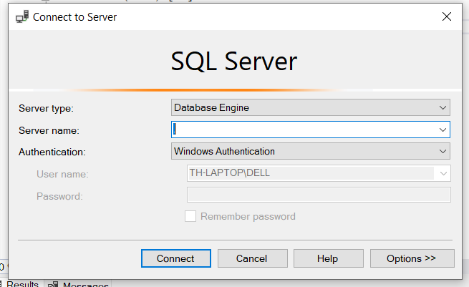

1. Create Database named “FengShuiNumberDb”

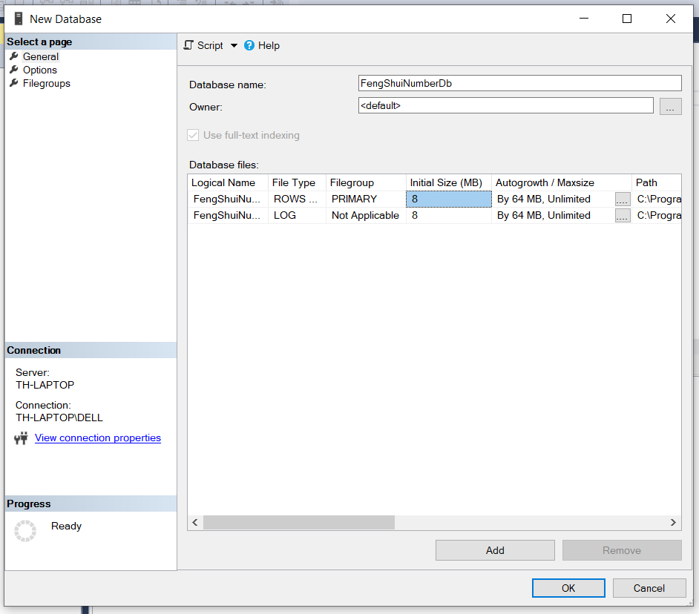

1. Open File “fengshuidb.sql” in “\FengShuiNumber\Database” with SQL Server Management Studio

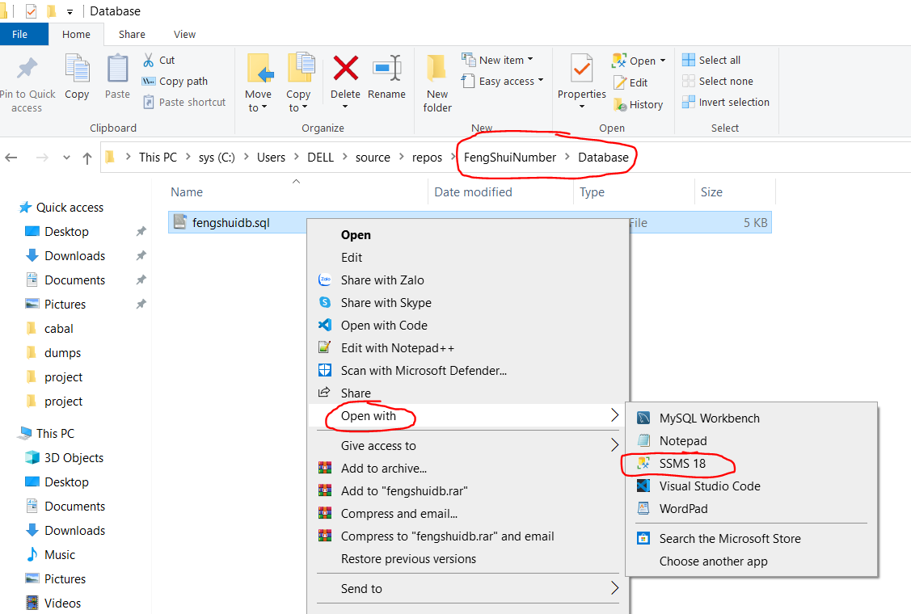

1. Run the SQL

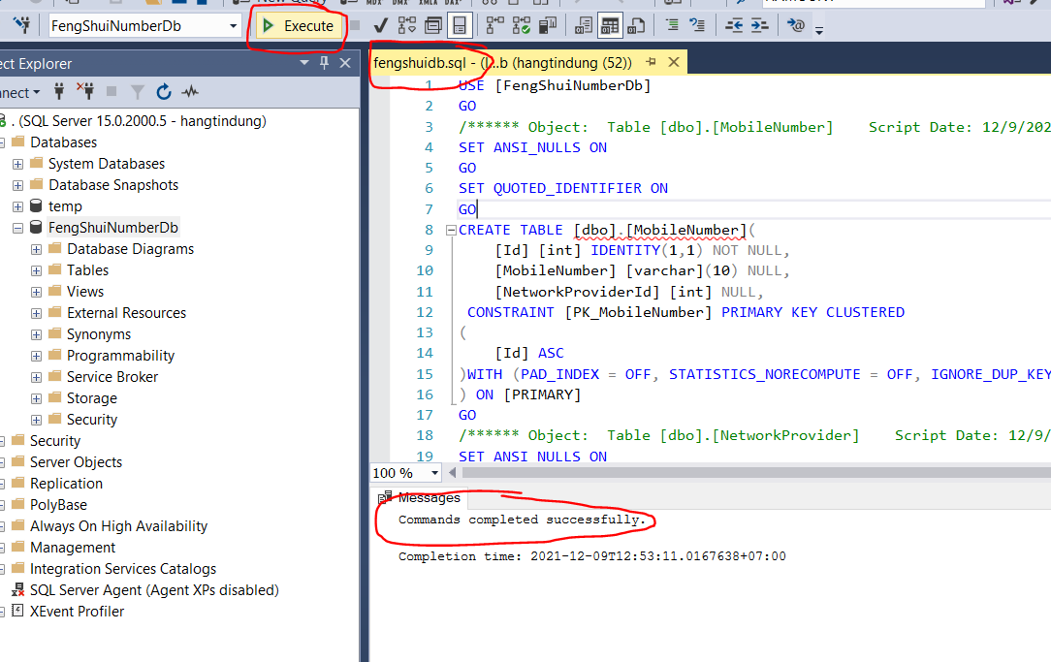

1. Open The App in “\FengShuiNumber\FengShuiNumber\bin\Debug\netcoreapp3.1\FengShuiNumber.exe”

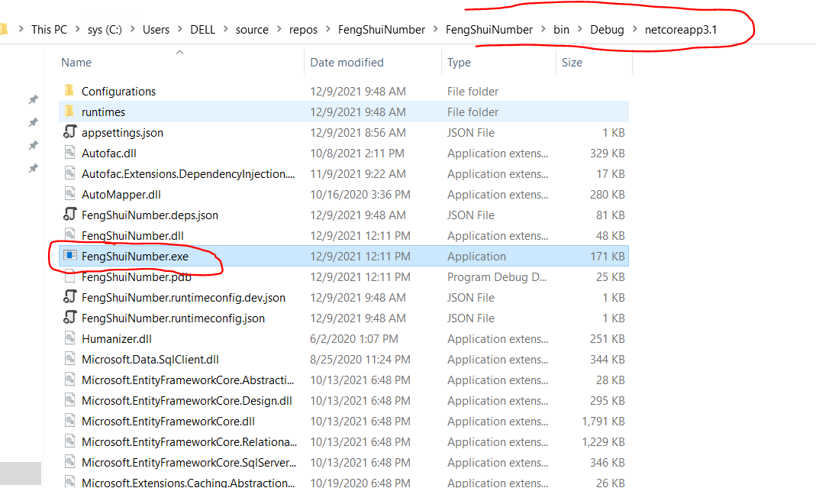

1. Test Result for first Run

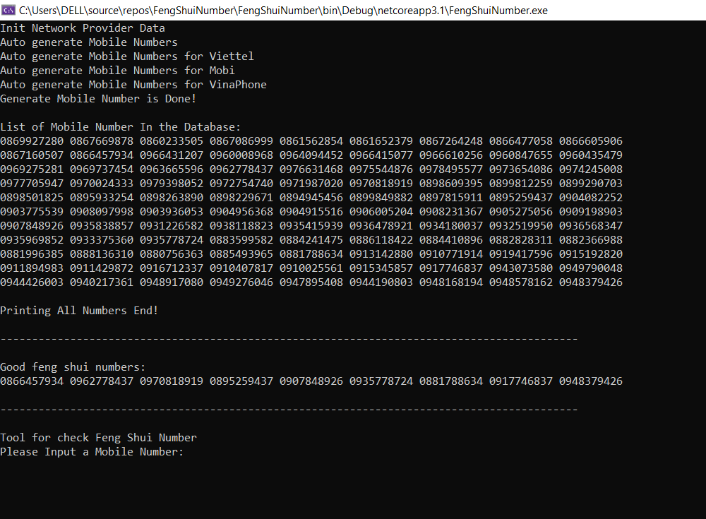

1. Test Result for second Run

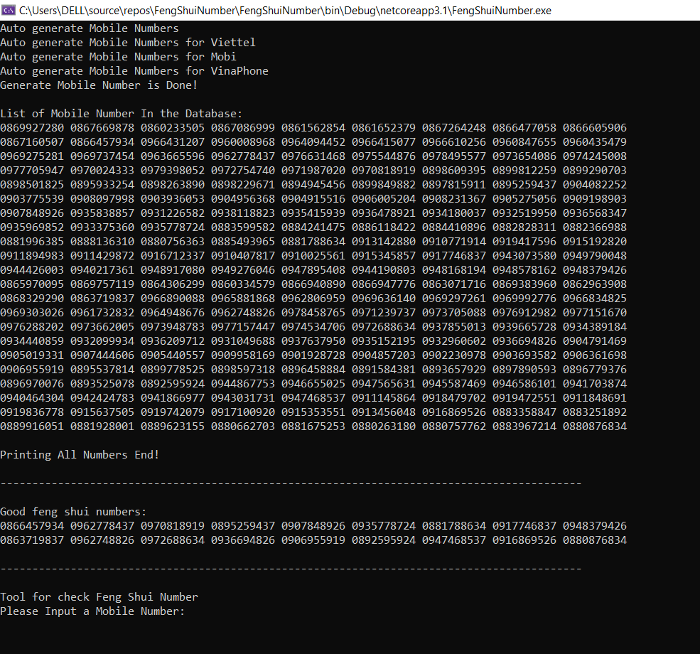

1. Test Result for third run

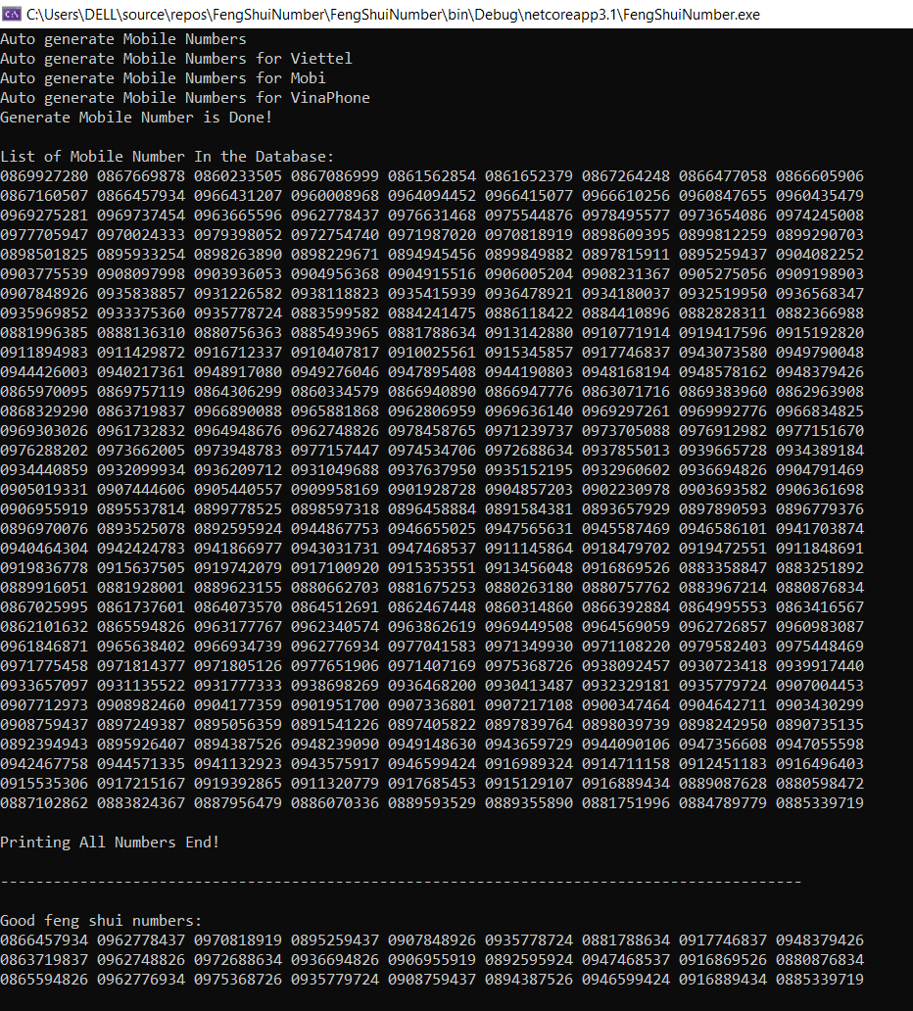

1. Tool for check Feng Shui Number

